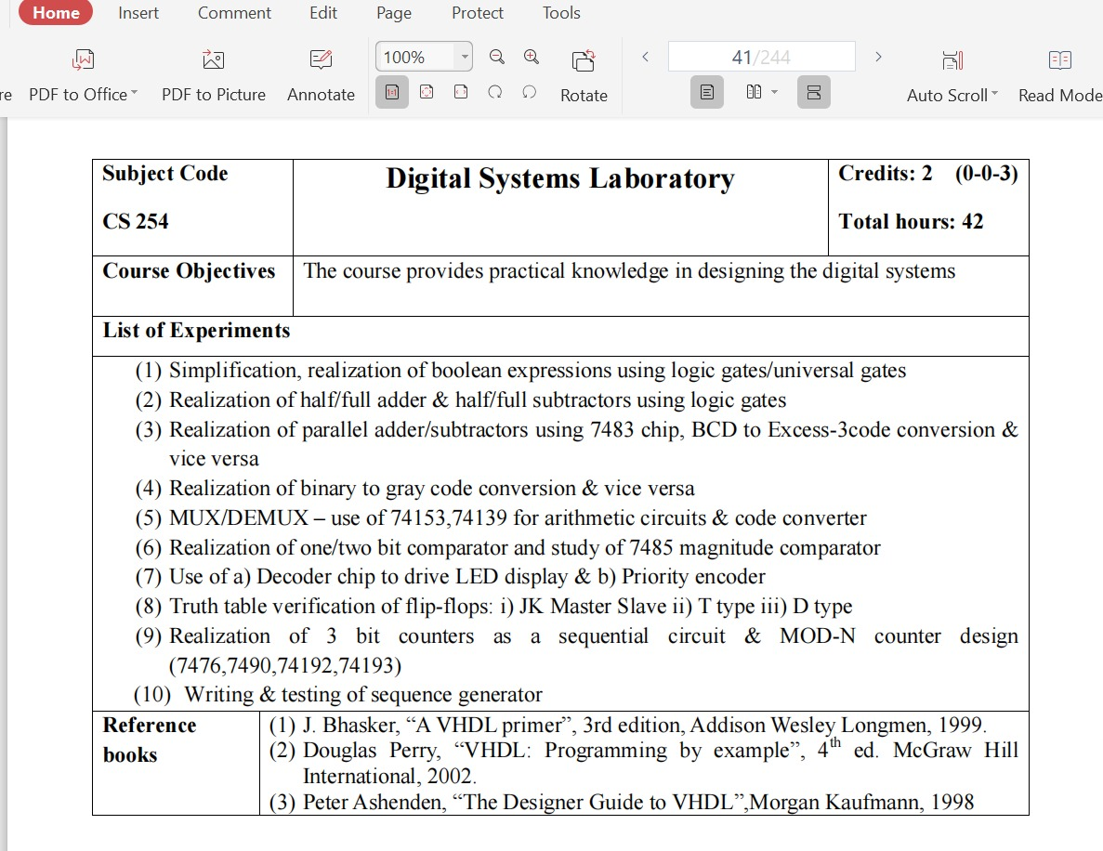**Experiment.1:** To simplify and realize Boolean Expression using Logic Gates/Universal Gates.

**AIM:** To Simplify and Realize Boolean Expressions Using Logic Gates/Universal Gates.

**APPARATUS REQUIRED: -** IC Trainer Kit, patch chords, IC7408, IC7432, IC7400, IC7402, IC 7404, IC 7486.

**Procedure:**

1. Place the IC in the socket of the trainer kit.

2. Make the connections as shown in the circuit diagram.

3. Apply the different combinations of input according to the truth table and verify the output.

**Simplification of expression: -**

Y=(A,B,C,D)= Σ(5,7,9,11,13,15)

Write the expression using K-map

Y=A’BC’D + A’BCD +AB’C’D+AB’CD + ABC’D + ABCD

Y =A’BD (C+C’) + AB’D(C+C’) + ABD(C+C’)

Y =A’BD + AB’D + ABD

Y =BD(A+A’) + AB’D

Y=BD + AB’D

Y=D(B+AB’)

Y=D(A+B)

Y =AD+BD

**Exercise:** Simplify and realize the following POS expn. and implement using NAND gates only: Y(A,B,C,D) = π (5,7,9,11,13,15)

**GIVEN EXPRESSION:**

Y=(A,B,C,D)= Σ(5,7,9,11,13,15)

**Truth-table:**

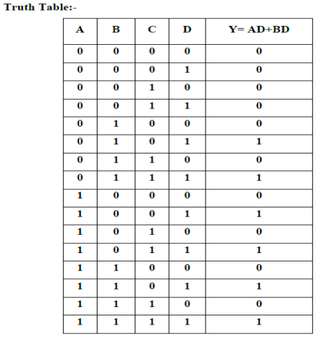

**Implementation:**

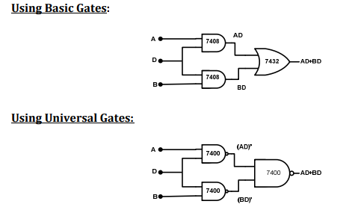

**Exercise:** Simplify and realize the following POS and implement using NAND gates only: Y(A,B,C,D)=π(5,7,9,11,13,15)

**Half Adder:**

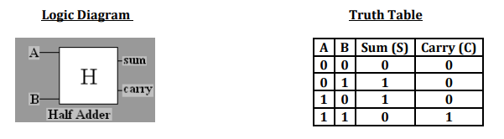

**Circuit Diagram:**

1. **USING BASIC AND XOR GATES**

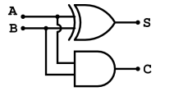

1. **USING NAND GATES ONLY**

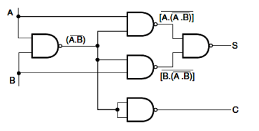

**Experiment 2**: HALF/FULL ADDER AND HALF/FULL SUBTRACTORS.

**Aim:** - To realize half/full adder and half/full subtractor.

i. Using X-OR and basic gates

ii. Using only NAND gates.

**Apparatus Required: -**

IC Trainer Kit, patch chords, IC 7486, IC 7432, IC 7408, IC 7400, etc.

**Procedure: -**

1. Verify the gates.

2. Make the connections as per the circuit diagram.

3. Switch on VCC and apply various combinations of input according to the truth table.

4. Note down the output readings for half/full adder and half/full subtractor sum/difference and the carry/borrow bit for different combinations of inputs.

**Exercise:** Implement half/full adder and half/full adder circuits using NOR gates only. Which is better, NAND or NOR? Why?

**Full Adder**

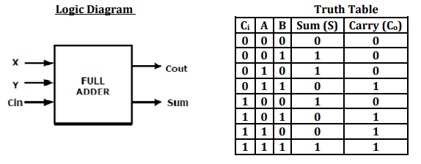

**Circuit Diagram**

**USING BASIC AND XOR GATES**

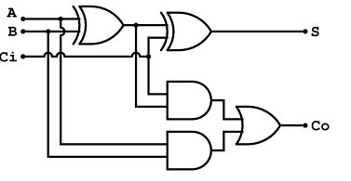

**USING NAND GATES ONLY**

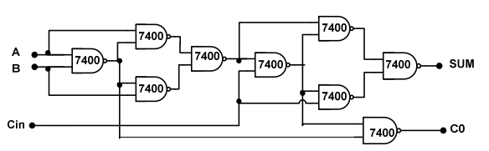

**Half subtractor**

**Logic Diagram**

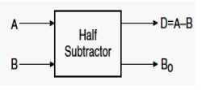

**Truth Table**

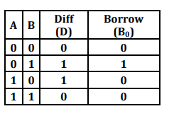

**Circuit Diagram**

**1.USING BASIC AND XOR GATES**

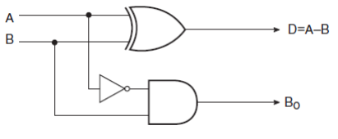

2. USING NAND GATES ONLY

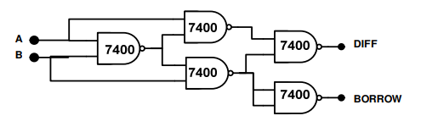

**Full subtractor**

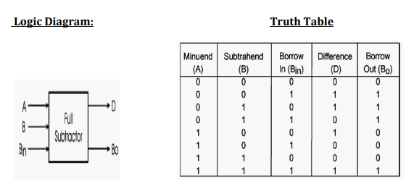

**Circuit Diagram**

**1.** **USING BASIC AND XOR GATES**

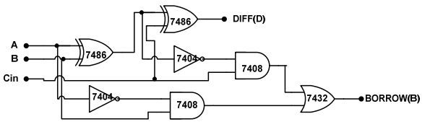

**2. USING NAND GATES ONLY**

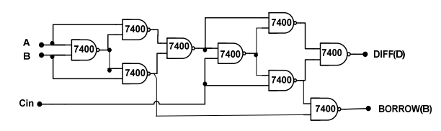

1. **Experiment: PARALLEL ADDER/SUBTRACTOR**

**AIM:** - To realize IC 7483 as parallel adder / Subtractor.

**Apparatus Required:** - IC Trainer Kit, patch chords, IC 7483, IC 7404, etc.

**Procedure: -**

1. Apply the inputs to A0 to A3 and B0 to B3.

2. Connect C0 to the Ground.

3. Check the output sum on the S0 to S3 and also C4.

4. For subtraction connect C0 to Vcc, Apply the B input through NOT gate, which gives the complement of B.

5. The truth table of adder and Subtractor are noted down.

**Exercise**: Implement a parallel adder/subtractor using IC 7483 and Xor gates.

**Pin Detail: -**

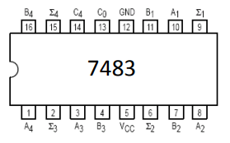

**Adder: -**

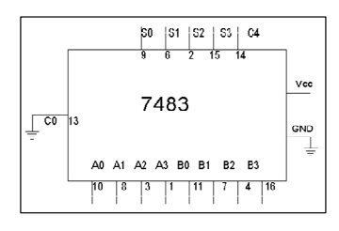

**Truth Table: -**

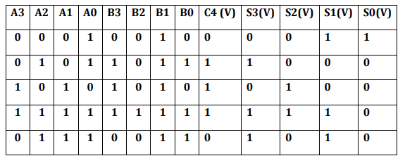

**Subtractor:-**

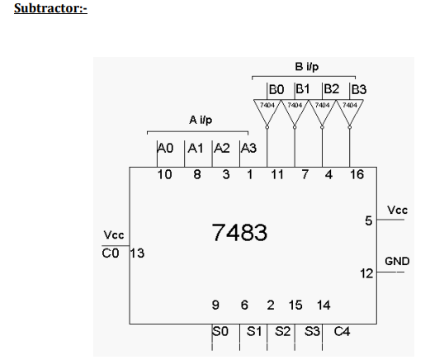

**Truth Table for Subtractor**

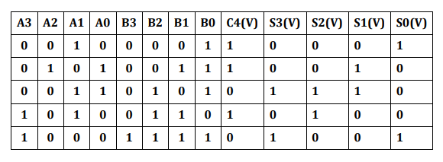

**II. BCD TO EXCESS-3 AND EXCESS-3 TO BCD CODE CONVERTER**

**AIM:** - To study and verify BCD to excess –3 code and excess-3 to BCD code conversion using NAND gates.

**APPARATUS REQUIRED: -** IC Trainer Kit, patch chords, IC 7400, IC 7404, etc.

**Procedure: - (BCD Excess 3 and Vice Versa)**

1. Make the connections as shown in the fig.

2. Pin [14] of all IC’S are connected to +5V and pin [7] to the ground.

3. The inputs are applied at E3, E2, E1, and E0 and the corresponding outputs at B3, B2, B1, and B0 are taken for excess – 3 to BCD.

4. The inputs are applied at B3, B2, B1, and B0 and the corresponding outputs are E3, E2, E1 and E0 for BCD to excess – 3.

5. Truth tables are verified.

**Exercise:** Implement BCD to excess-3 and excess-3 to BCD code converter using parallel adder IC 7483.

**BCD To Excess-3:**

**Truth Table For Code Conversion: -**

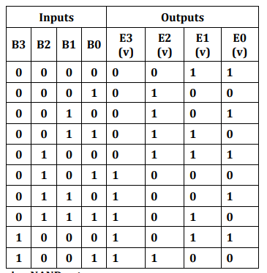

**Circuit diagram using NAND gates**

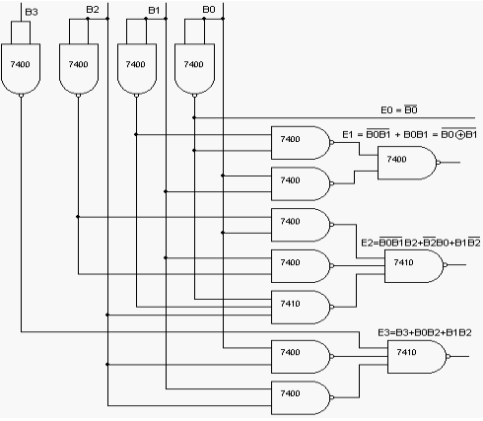

**Excess-3 To BCD :-**

**Truth Table For Code Conversion: -**

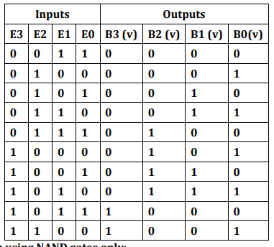

**Circuit diagram using NAND gates only:**

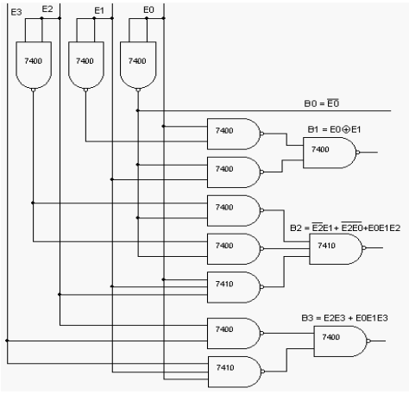

**Experience :** **BINARY-TO-GRAY AND GRAY-TO-BINARY CODE CONVERTER**

**AIM:** - To convert given binary numbers to gray codes.

**APPARATUS REQUIRED:** - IC Trainer Kit, patch chords, IC 7486, etc

**PROCEDURE: -**

1. The circuit connections are made as shown in fig.

2. Pin (14) is connected to +Vcc and Pin (7) to ground.

3. In the case of binary to gray conversion, the inputs B0, B1, B2 and B3 are given at respective pins and outputs G0, G1, G2, G3 are taken for all the 16 combinations of the input.

4. In the case of gray to binary conversion, the inputs G0, G1, G2 and G3 are given at respective pins and outputs B0, B1, B2, and B3 are taken for all the 16 combinations of inputs.

5. The values of the outputs are tabulated.

**Exercise:**

Implement binary to gray and gray to binary code converter using NAND gates only.

**Binary to Gray:**

**Truth-table:**

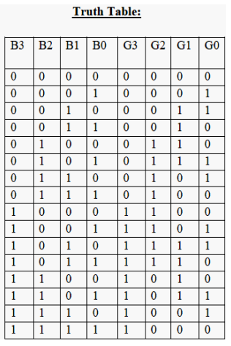

**Circuit diagram using EX-OR Gates:**

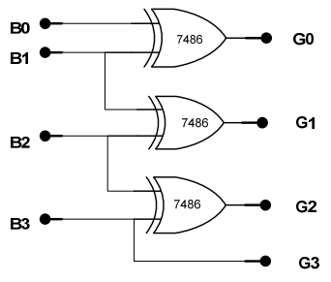

**Gray to binary:**

**Truth-table:**

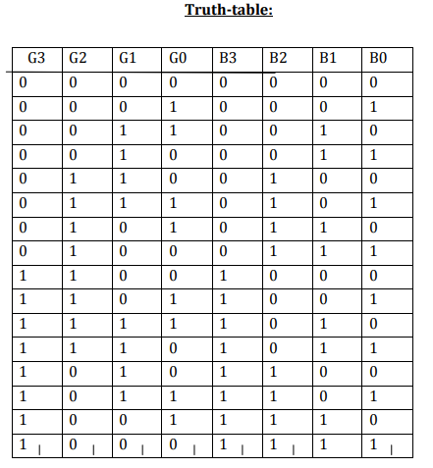

**Circuit Diagram using EX-OR Gates**

